Independent Reading Log Menu
- Complete one activity for each week. Be ready to hand in your work each Friday at the beginning of class.
- Write on a sheet of clean notebook paper.
- Put the activity number and the title of your book at the top of the paper.
- Each assignment should be at least ¾ of a page and should completely respond to the prompt.
1.1: Make a list of at least three predictions for the book—think about characters, setting, and genre. As you read the first few chapters, write down whether your predictions were accurate.
2.1: List three characters in the book so far. Describe their physical appearance, importance to the story, and character traits.
3.1: Write a letter to a character in the book. Include your reaction to the events in the book, your feelings about the character’s choices, and what you think the character should do now.
4.1: Theme is the underlying message of a piece of text. Write 2-3 paragraphs about what you think is the theme of this book.
1.2: Write a list of at least five events that have happened so far. Make a prediction about what the conflict, or problem, will be. Be as specific as possible.
2.2: Make a list of six events in the story. What caused each event? What was the effect of each event?
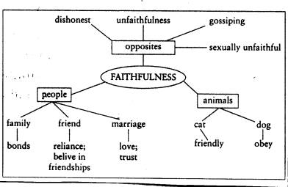
3.2: Choose five interesting or unusual words from the book so far. Create a semantic map for each, including definition, the word in a sentence, related words, and synonyms. (see diagram)
4.2: Style is the way an author writes a text. How do you feel about the author’s style in this book? Is it formal or informal? Do you like the way the sentences sound?
1.3: The first few chapters of a book often contain a detailed description of the setting. Find a page with many setting details. Draw a picture of the setting. Label at least five specific details from the text. Color the drawing.
2.3: Describe an exciting event from the book as if you were a sports broadcaster.
3.3: Think about the relationship of the setting to the story. Could this story have happened in another place? Why or why not?
4.3: Often, characters change as a result of events in a novel. Describe the changes that a character went through in this book.
Name
Date
End of book form
Complete this form if you have finished an independent reading book.
Title of book
Author
# of pages
Would you recommend this book to other students?

Why or why not? (Be specific!)

What was your favorite (or least favorite!) part about this book?

On a separate sheet of notebook paper, complete one of the activities below. Each response should be AT LEAST one full page in length, typed or handwritten.

Option 1 Create a story map for this book. Include the five story elements that we have talked
about in class: characters, setting, conflict, plot (at least five events), and theme.

Option 2 Write a letter to me about your reactions to this book. Include information about how
the main character changed throughout the book, how the ending was or was not surprising, how
the conflict was resolved, and what you learned from reading the book.

